### sh GenralP1

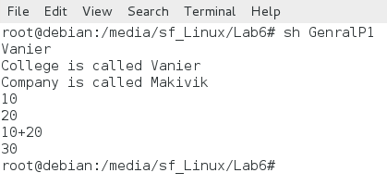

### sh Sum1

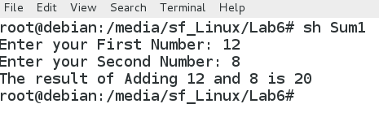

### sh EmployeeSumReport

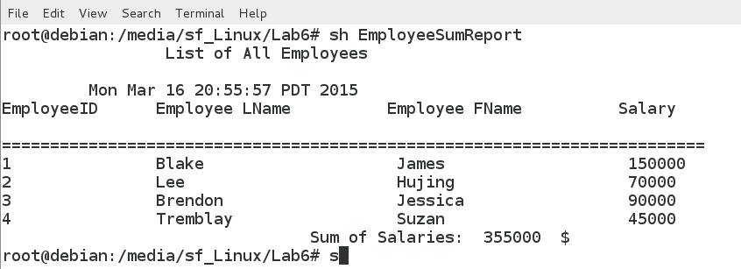

### sh Program1

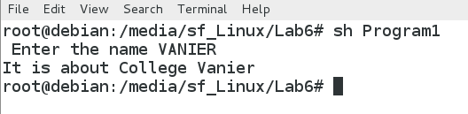

### sh Program2

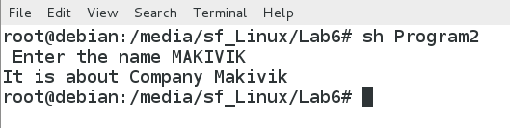

### sh Substract1

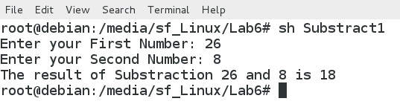

### sh Product1

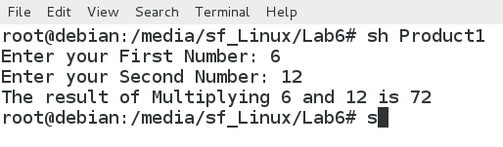

### sh MathOperation

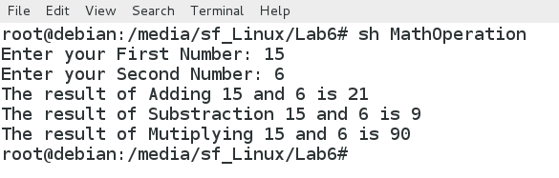

Project 6-2

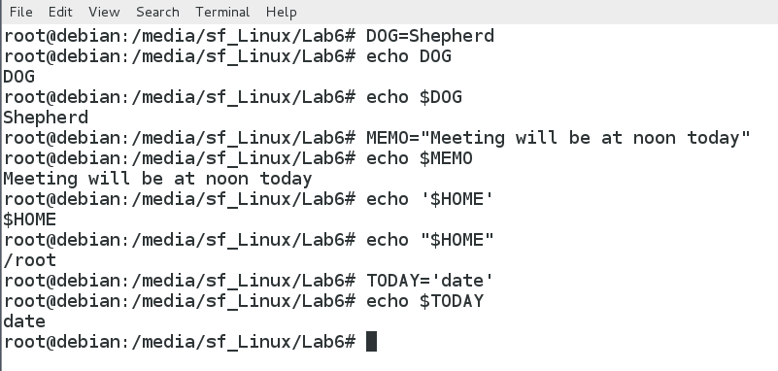

Project 6-3

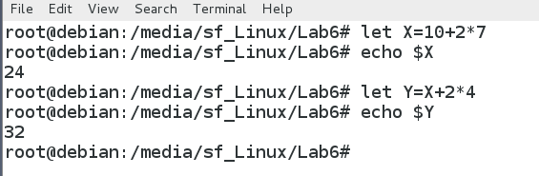

Project 6-7

